# The Statistical Guide to a Silver Buckle

sdf

## Introduction

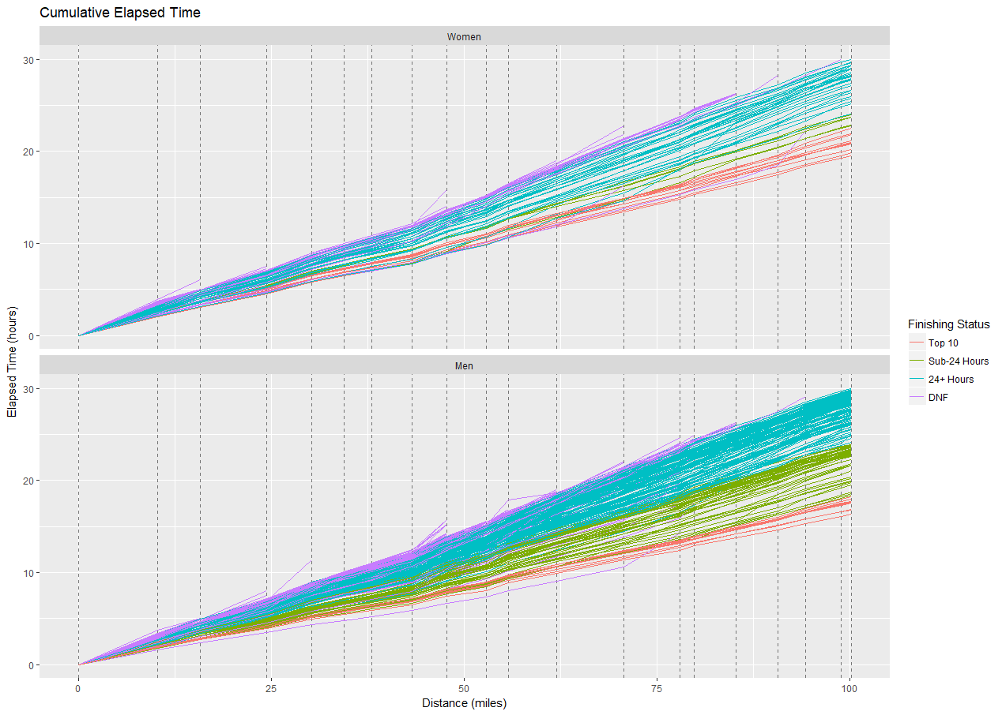

Table 1 shows the breakdown of finishing status for all 369 starters. Table 2 shows the same breakdown but in percentage terms. Overall, a total of 76 silver buckles were awarded, representing about 20% of the starters. Of the 80% who failed to earn a silver buckle, approximately 47% finished over 24 hours and 33% did not finish.

|  |  |  |  |
| --- | --- | --- | --- |
|  | **Female** | **Male** | **Total** |
| **Top 10** | 10 | 10 | *20* |
| **Sub-24 Hours** | 5 | 51 | *56* |
| **24+ Hours** | 31 | 141 | *172* |
| **DNF** | 39 | 82 | *121* |
| ***Total*** | *85* | *284* | *369* |

***Table 1:*** *Finishing status count by gender*

|  |  |  |  |
| --- | --- | --- | --- |
|  | **Female** | **Male** | **Total** |
| **Top 10** | 12% | 4% | *5%* |
| **Sub-24 Hours** | 6% | 18% | *15%* |
| **24+ Hours** | 36% | 50% | *47%* |
| **DNF** | 46% | 29% | *33%* |
| ***Total*** | *100%* | *100%* | *100%* |

***Table 2:*** *Finishing status proportion by gender*

## Official Silver Buckle Pace

The Western States race directors publish a

## Building a Model for Silver Buckle Pace

For any given aid station, we have a record of each runner’s cumulative time and their ultimate finishing status (silver buckle or not). We can ask: given a runner’s cumulative time to that point, how likely are they to ultimately earn a silver buckle? This type of problem is well-suited to a simple logistic regression model. Logistic models take a set of inputs (in our case just cumulative time) and output the likelihood of observing one of two binary states (in our case earning a silver buckle or not).

Let’s look at a specific example. We’ll look at the Foresthill aid station, which is mile 62. A total of 301 runners reached this aid station. Of those 301 runners, 76 went on to earn a silver buckle. The other 225 runners did not (171 finished in more than 24 hours and 54 did not finish). Ideally, there would be a single point such that all runners who arrived at Foresthill prior to that point earned a silver buckle and all those who arrived after did not. Of course, reality is not so simple. There were many fast runners who arrived at Foresthill early yet failed to finish (Jim Walmsley is one example). There were also many runners who arrived at Foresthill relatively slowly yet rallied hard to finish under 24 hours. (We will examine several of these examples later.)

Chart 1 below shows each runner as a single point. Their position on the x-axis is their cumulative time upon reaching Foresthill. Their position on the y-axis is either 0 (failed to earn a silver buckle) or 1 (earned a silver buckle). (Note that the points have been vertically “jittered” by a small amount to more clearly display otherwise overlapping points.) The logistic regression model essentially constructs a backwards “S” shaped curve which assigns a probability to each point of being in the silver-buckle category.

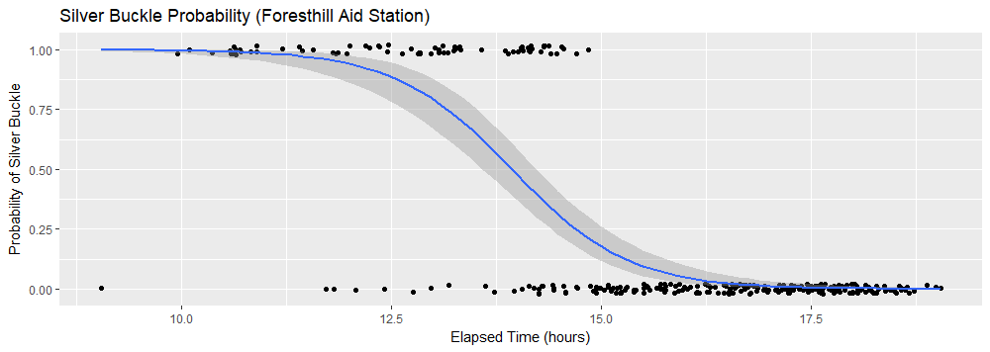***Chart 1:*** *Logistic regression model for Foresthill aid station.*

As you can see, the model does a good job for those runners reaching Foresthill in less than 12.5 hours (assigning close to 100% likelihood) and those runners arriving in more than 15 hours (assigning close to 0% likelihood). Between 12.5 and 15 hours, things are not as clean but the model is fit to minimize the total error rate.

Given this model, we can look for the point at which the model assigns a 50% probability. In the case of Foresthill, this occurs at 13 hours and 56 minutes. This means that if a large (theoretical) group of runners arrived at Foresthill at exactly 13:56, about half would eventually earn a silver buckle and half would not. We can therefore take 13:56 as the “empirical” 24-hour silver-buckle pace to this aid station. We can then repeat this process for each of the 20 aid stations for which we have runner data and construct a complete 24-hour pace chart.

## Empirical Results

Table 1 compares our model’s empirical silver-buckle pace and the official pace. You can see that they generally agree for the first 62 miles of the race. Beyond that, however, our empirical model actually differs from the official model by more than 30 minutes later in the race. In particular, while the official pace at Quarry Road (90.7 miles) is 21:10, our empirical model still assigns a 50% probability of a silver buckle for a runner arriving at 21:43, a full 32 minutes later (and less than 10 miles from the finish).

|  |  |  |  |  |
| --- | --- | --- | --- | --- |
| **Aid Name** | **Aid Distance** | **Official Pace** | **Empirical Pace** | **Diff** |
| Start | 0.0 | 0:00 | 0:00 | 0:00 |
| Lyon Ridge | 10.3 | 2:10 | 2:16 | 0:05 |
| Red Star Ridge | 15.8 | 3:20 | 3:26 | 0:05 |
| Duncan Canyon | 24.4 | 5:00 | 4:59 | -0:01 |
| Robinson Flat | 30.3 | 6:30 | 6:27 | -0:03 |
| Miller's Defeat | 34.4 | 7:15 | 7:12 | -0:02 |
| Dusty Corners | 38.0 | 7:55 | 7:50 | -0:05 |
| Last Chance | 43.3 | 8:55 | 8:45 | -0:10 |
| Devil's Thumb | 47.8 | 10:15 | 10:09 | -0:05 |
| El Dorado Creek | 52.9 | 11:20 | 11:20 | 0:00 |
| Michigan Bluff | 55.7 | 12:20 | 12:19 | -0:01 |
| Foresthill | 62.0 | 13:45 | 13:56 | 0:11 |
| Peachstone | 70.7 | 15:45 | 16:07 | 0:21 |
| Rucky Chucky | 78.0 | 17:40 | 18:02 | 0:21 |
| Green Gate | 79.8 | 18:20 | 18:45 | 0:25 |
| Auburn Lake Trails | 85.2 | 19:50 | 20:14 | 0:23 |
| Quarry Road | 90.7 | 21:10 | 21:43 | 0:32 |
| Pointed Rocks | 94.3 | 22:20 | 22:43 | 0:22 |
| Robie Point | 98.9 | 23:40 | 23:46 | 0:06 |
| Finish Line | 100.2 | 24:00 | 24:00 | 0:00 |

***Table 1:*** *Official and Empirical Pace Chart*

Chart 2 shows these differences in graphical form. Relative to the empirical pace, the official pace appears to be about 10 minutes too slow at Last Chance (mile 43.3) and consistently 20-30 minutes too fast from Peachstone (70.0) to Pointed Rocks (94.3). In other words, for a runner who finds themselves slipping behind the official 24-hour pace after Foresthill, do not despair! Evidence suggests you have better than a 50% chance of rallying to that silver buckle if you can keep within about 20 minutes of the official pace.

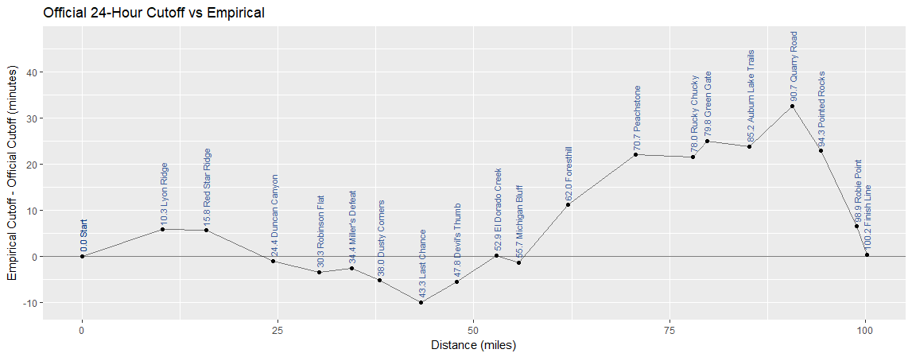

***Chart 2:*** *Difference between empirical 24-hour pace and official pace*

## Evaluating Model Accuracy

Now that we have a model which outputs a likelihood of earning a silver buckle for each runner at a particular aid station, we can evaluate its accuracy. We will do this in a very simple manner: if the model assigns a likelihood above 50% for a particular runner, we will categorize that runner as “predicted silver buckle”. If the model assigns a likelihood below 50%, we will categorize that runner as “predicted no silver buckle”. We then have the following for possibilities of model outcome:

|  |  |  |  |
| --- | --- | --- | --- |
|  |  | Actual Outcome | |
|  |  | Silver Buckle | No Silver Buckle |
| Model Prediction | Silver Buckle | True Positive | False Positive |
| No Silver Buckle | False Negative | True Negative |

Our accuracy will then be given by:

Chart 3 shows our model’s accuracy for each aid station. Interestingly, the model is actually quite accurate, even for early aid stations. In particular, our model correctly categorized over 87% of all runners who arrived at the Lyon Ridge aid station (mile 10.3). While the accuracy hovers around 87-90% for the first 70 miles, the accuracy rises sharply by Rucky Chucky (mile 78) and Green Gate (mile 79.8). By Auburn Lake Trails, the model is correctly categorizing over 97% of all runners correctly. At Robie Point (mile 98.9) the model is fully 100% accurate. Of course, it doesn’t take much effort to tell who is going to break 24 hours when you’re only 1.3 miles from the finish!

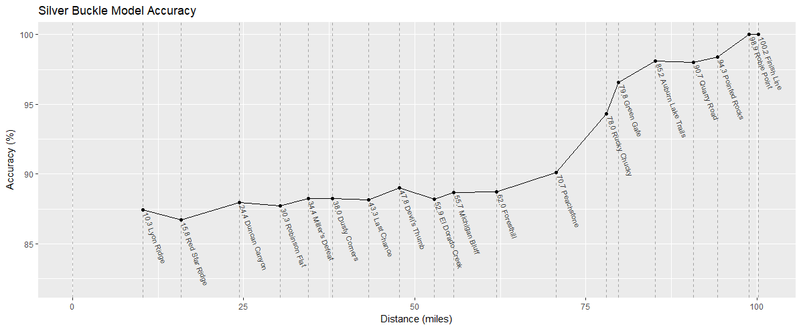 ***Chart 3:*** *Model accuracy by aid station*

Now that we have built a model for empirical 24-hour pace, let’s revisit Chart 1 and overlay this pace. Chart 4 shows the result. It appears that the model did a decent job separating the silver buckle winners (pink and green) from the non-silver buckle winners (blue and purple). It also appears that there were a handful of silver buckle winners who were behind 24-hour pace for a significant portion of the race. We will investigate these runners in more detail later.

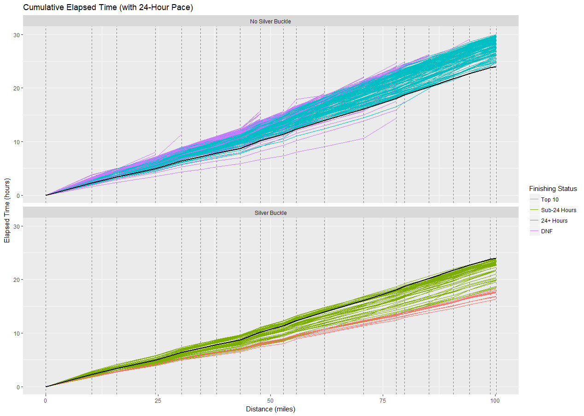

***Chart 4:*** *Cumulative elapsed time with empirical 24-hour pace*

## Empirical Silver Buckle Pace by Segment

Now that we have built a model of the empirical, cumulative 24-hour pace to each aid station, we can examine each segment and compute the model pace over that portion of the course. Chart 5 shows the 19 segments and the pace required in order to stay on silver buckle pace.

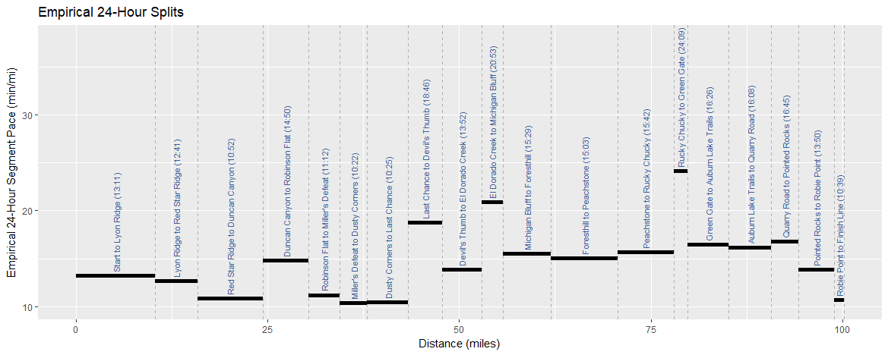

***Chart 5:*** *Empirical model pace by segment*

Not surprisingly, the pace varies widely throughout the race. While the overall silver buckle pace works out to 14:22 min/mile, there are some segments which are significantly slower. In particular, the climb from the Rucky Chucky river crossing to Green Gate (mile 78 to 79.8) is a 24:09 min/mile pace. Likewise, the climb from El Dorado Creek to Michigan Bluff (mile 52.9 to 55.7) is a 20:53 min/mile pace. On the flip side, the final mile from Robie Point to the finish (mile 98.9 to 100.2) is a 10:39 min/mile pace. The segments from Miller’s Defeat to Dusty Corners (mile 34.4 to 38) and from Dusty Corners to Last Chance (mile 38 to 43.3) are also quite fast at 10:22 min/mile and 10:25 min/mile, respectively.

|  |  |  |  |  |
| --- | --- | --- | --- | --- |
| **Segment** | **Segment Distance** | **Cumulative Distance** | **Segment Pace** | **Cumulative Pace** |
| Start to Lyon Ridge | 10.3 | 10.3 | 13:11 | 13:11 |
| Lyon Ridge to Red Star Ridge | 5.5 | 15.8 | 12:41 | 13:01 |
| Red Star Ridge to Duncan Canyon | 8.6 | 24.4 | 10:52 | 12:15 |
| Duncan Canyon to Robinson Flat | 5.9 | 30.3 | 14:50 | 12:45 |
| Robinson Flat to Miller's Defeat | 4.1 | 34.4 | 11:12 | 12:34 |
| Miller's Defeat to Dusty Corners | 3.6 | 38.0 | 10:22 | 12:22 |
| Dusty Corners to Last Chance | 5.3 | 43.3 | 10:25 | 12:07 |
| Last Chance to Devil's Thumb | 4.5 | 47.8 | 18:46 | 12:45 |
| Devil's Thumb to El Dorado Creek | 5.1 | 52.9 | 13:52 | 12:51 |
| El Dorado Creek to Michigan Bluff | 2.8 | 55.7 | 20:53 | 13:16 |
| Michigan Bluff to Foresthill | 6.3 | 62.0 | 15:29 | 13:29 |
| Foresthill to Peachstone | 8.7 | 70.7 | 15:03 | 13:41 |
| Peachstone to Rucky Chucky | 7.3 | 78.0 | 15:42 | 13:52 |
| Rucky Chucky to Green Gate | 1.8 | 79.8 | 24:09 | 14:06 |
| Green Gate to Auburn Lake Trails | 5.4 | 85.2 | 16:26 | 14:15 |
| Auburn Lake Trails to Quarry Road | 5.5 | 90.7 | 16:08 | 14:22 |
| Quarry Road to Pointed Rocks | 3.6 | 94.3 | 16:45 | 14:27 |
| Pointed Rocks to Robie Point | 4.6 | 98.9 | 13:50 | 14:25 |
| Robie Point to Finish Line | 1.3 | 100.2 | 10:39 | 14:22 |

***Table 3:*** *Empirical segment pace*

Table 3 shows the segment pace and cumulative pace in minutes/mile for each of the 19 segments.

Chart 6 is the segment pace chart with pace of each of the top ten men overlaid. Perhaps not surprisingly, all ten men ran every segment under 24-hour pace (with the exception of the final mile from Robie Point to the finish). Of particular note, all ten men ran more than 5:00 min/mile under silver-buckle pace from Foresthill (mile 62) to the Rucky Chucky river crossing (mile 78).

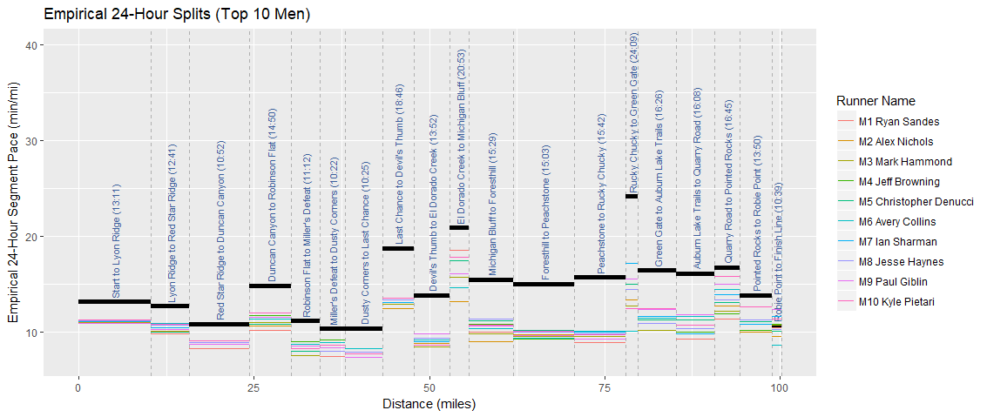

***Chart 6:*** *Empirical model pace by segment with Top 10 men*

Chart 7 shows the same for the top ten women. Unlike the men, however, we can see that several ladies began the race conservatively and accelerated later. In fact, six of the eventual top ten women would run the first segment from the start to Lyon Ridge (mile 10.3) behind silver-buckle pace.

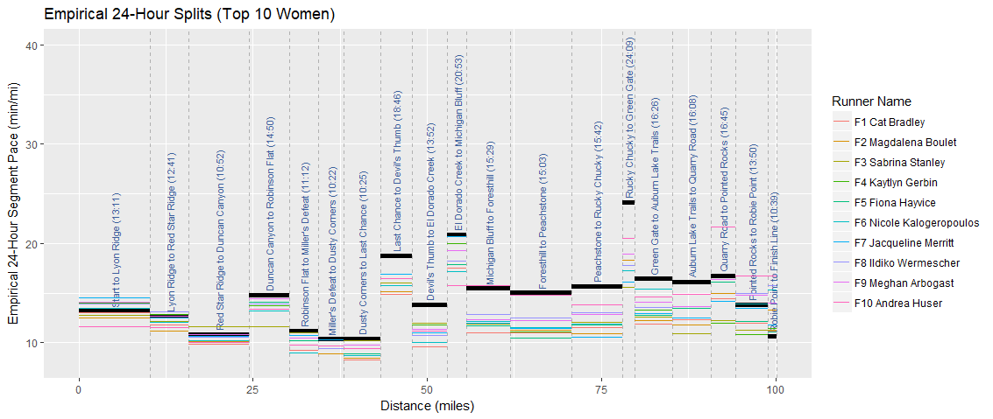

***Chart 7:*** *Empirical model pace by segment with Top 10 men*

## Aid Station Pace Chart

Chart 8 shows the relationship between each runner’s elapsed time and their final finishing time at each aid station. We have assigned a finishing time of 30:00 to all runners who failed to finish (DNF). In each chart, the horizontal line represents a 24-hour finish. The vertical line represents the empirical silver buckle pace to the given aid station. The points are colored by final finishing status.

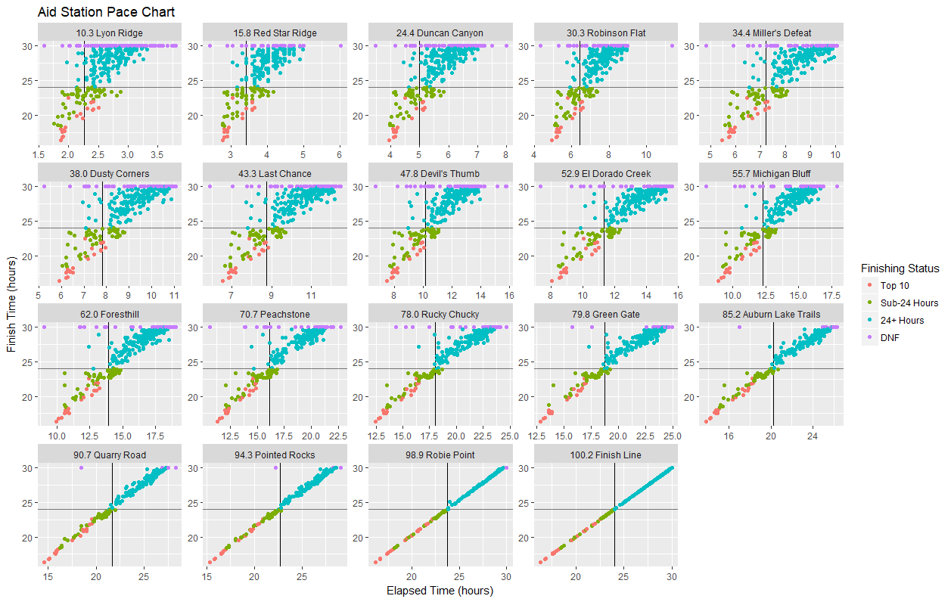

***Chart 8:*** *Relationship between elapsed time to aid station and evetual finishing time*

These charts provide a method of visually inspecting the model accuracy that we computed earlier. In particular, the more accurate the model, the better it will separate the silver buckle winners (Top 10 and Sub-24 Hours) to the left of the vertical line and the non-silver buckle winners (24+ Hours and DNF) to the right of the line. You can see that the early aid stations still contain a good bit of mixing, but the two categories sort themselves out as the race progresses.

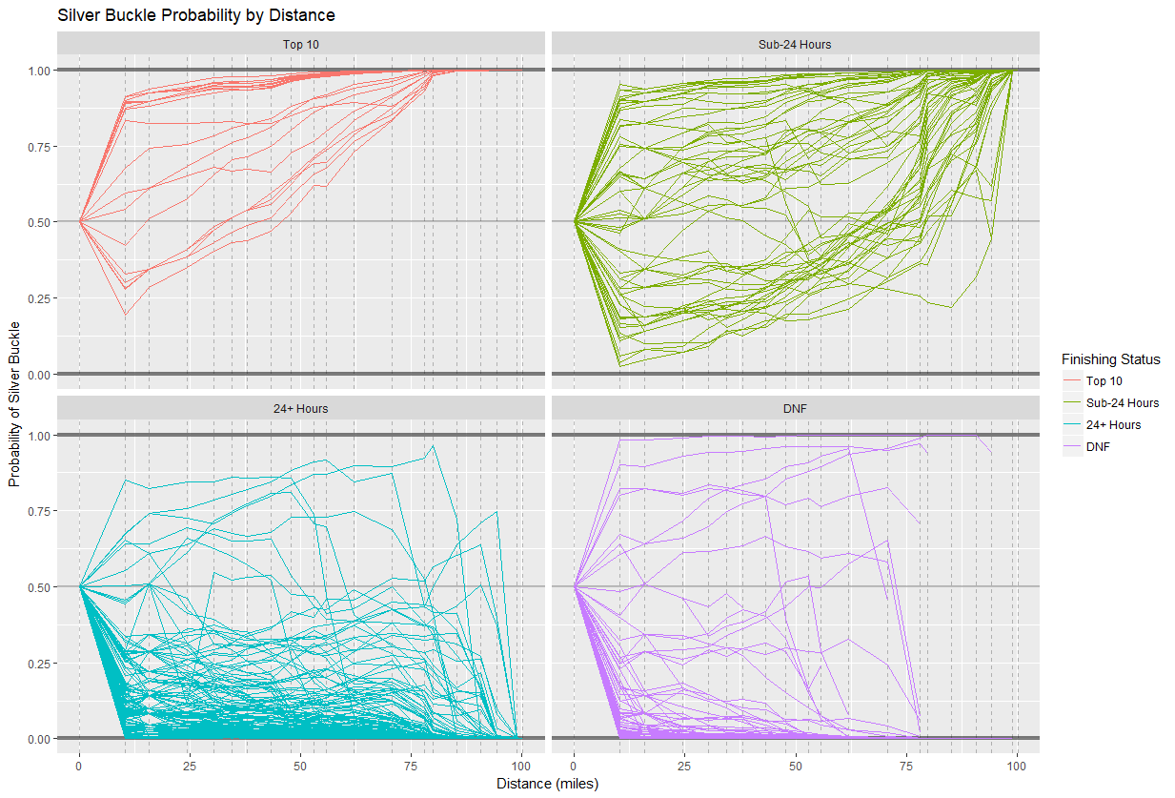

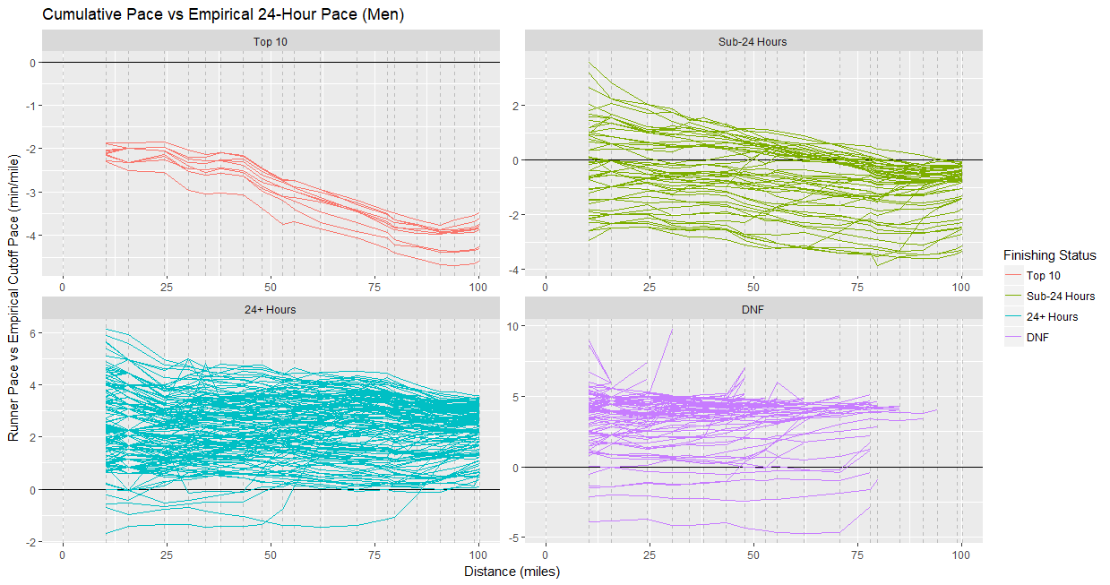

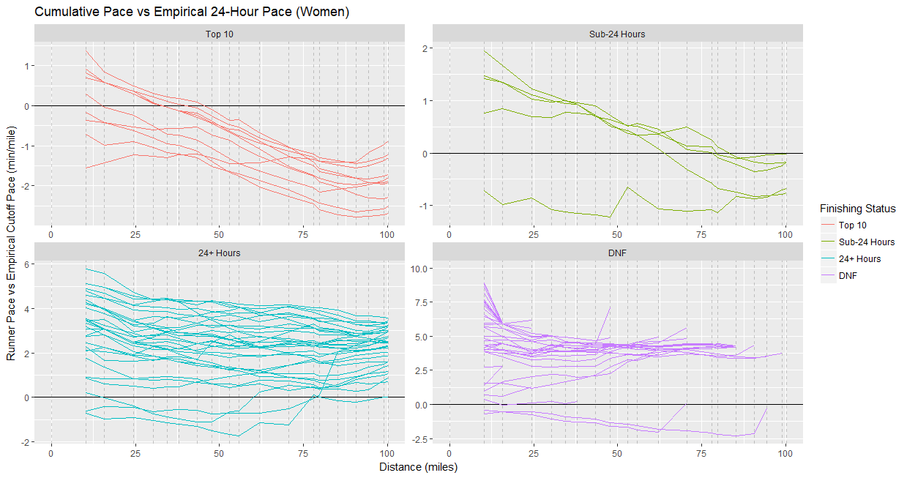

## Aid Station Spectator Guide

Until now, we’ve focused on pacing from a runner’s perspective. In this section, we consider things from the perspective of a spectator at a given aid station. In particular, we ask the question: “Given that I see a runner arrive under (or over) the empirical silver buckle pace, what are the chances they eventually earn (or fail to earn) a silver buckle?”

To answer this question, we can utilize one of the core theorems of probability: Bayes’ Theorem. Mathematically, Bayes’ Theorem states:

In our case, we can let *A* represent “earns silver buckle” and *B* represent “arrived ahead of 24-hour pace”. In that case, we have:

Let’s look at the concrete example of a spectator at Foresthill (mile 62). Given that we observe a runner arrive ahead of silver buckle pace, what is the likelihood that they eventually earn a silver buckle? In this case, we have the following runner counts:

|  |  |  |  |
| --- | --- | --- | --- |
|  | **Ahead of Pace** | **Behind Pace** | ***Total*** |
| **Silver Buckle** | 52 | 24 | *76* |
| **No Silver Buckle** | 10 | 215 | *225* |
| ***Total*** | *62* | *239* | *301* |

Therefore,

And finally,

Therefore, when we observe a runner pass through Foresthill under 13:56, we can be approximately 84% confident that they will go on to earn the coveted silver buckle. Conversely, there is a 16% likelihood they will not.

If we repeat this process for each of the aid stations (and expand from two categories of finishing status to four), we arrive at the data presented in Chart 9. The left chart shows the likelihood of each finishing status for those runners arriving over the empirical silver buckle pace. The right chart shows the same for those runners arriving under the empirical pace.

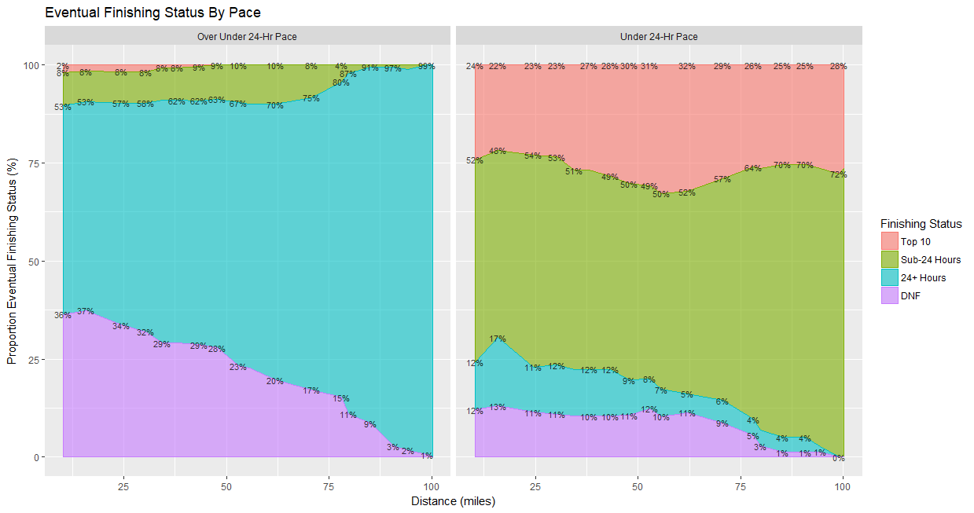

***Chart 9:*** *Conditional likelihood of finishing status by aid station and pace*

A few things become apparent with these charts. First, for those runners arriving at the first aid station (Lyon Ridge, mile 10.3) behind pace, there is around a 36% likelihood of an eventual DNF. This likelihood steadily declines as those runners exit the race. We see a “survival of the fittest” pattern emerge whereby the field grows stronger as the race progresses and the likelihood of a DNF declines with each mile. Interestingly, however, the likelihood of a DNF for those runners arriving ahead of silver buckle pace holds steady around 10% all the way to Peachstone (mile 70.7).

Second, for those runners arriving behind silver buckle pace, there is about a 10% chance of rallying to an eventual silver buckle. This 10% likelihood exists all the way to the Foresthill (mile 62) aid station. After that, however, the likelihood rapidly shrinks to near zero at Auburn Lake Trails (mile 85.5). In other words, for a small portion of the field, rallying from behind 24-hour pace to a silver buckle finish is possible but the rally needs to begin by Foresthill. Starting any later and the likelihood rapidly diminishes.

## The Silver Buckle Frontier

*Question: What is the farthest behind 24-hour pace a runner can be and still earn a silver buckle?*

Recall that our empirical silver buckle pace represented the pace such that the likelihood of an eventual silver buckle finish was exactly 50%. Thus, it is likely that there will be a subset of the field that runs behind model pace for a portion of the race but finishes strong and nonetheless earns a silver buckle. How far back were these runners?

First, let’s examine the data visually. Chart 10 shows the elapsed time of each male runner relative to the empirical 24-hour pace. The most relevant chart is the one for Sub-24 Hour runners. Of the 51 runners in this category, 25 fell behind 24-hour pace at some point yet rallied to finish under 24 hours. (None of the top 10 men were ever behind silver buckle pace.) Conversely, for the 141 runners who finished in more than 24 hours, only 11 were ever ahead of silver buckle pace at any point.

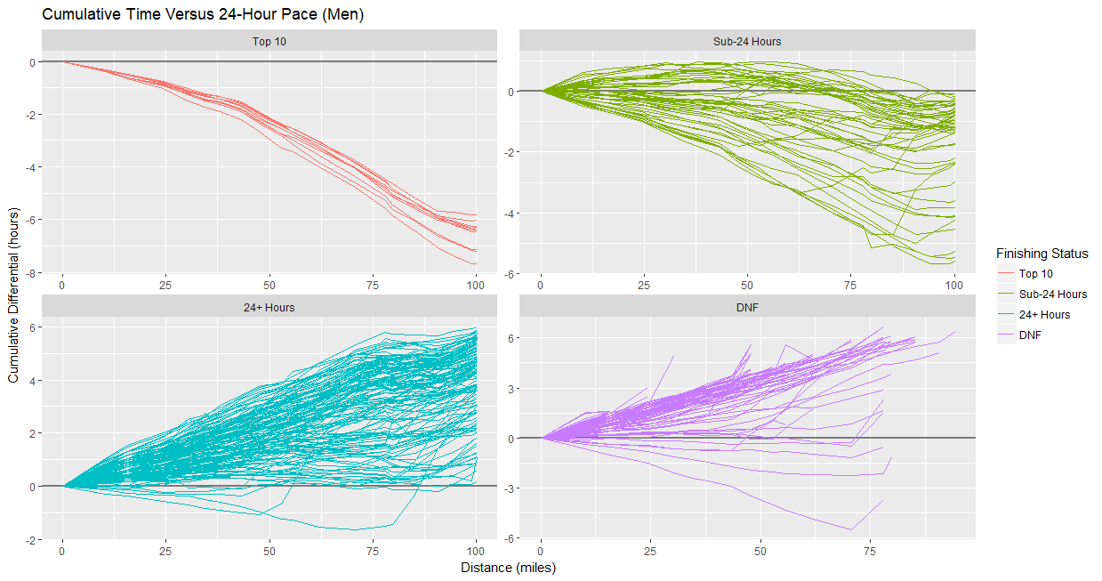

***Chart 10:*** *Elapsed time relative to silver buckle pace (men)*

Chart 11 shows the same for the women. Unlike the men, six of the top ten women were behind pace at some point. Additionally, four of the five women who earned a silver buckle outside the top ten were behind pace by at least 30 minutes.

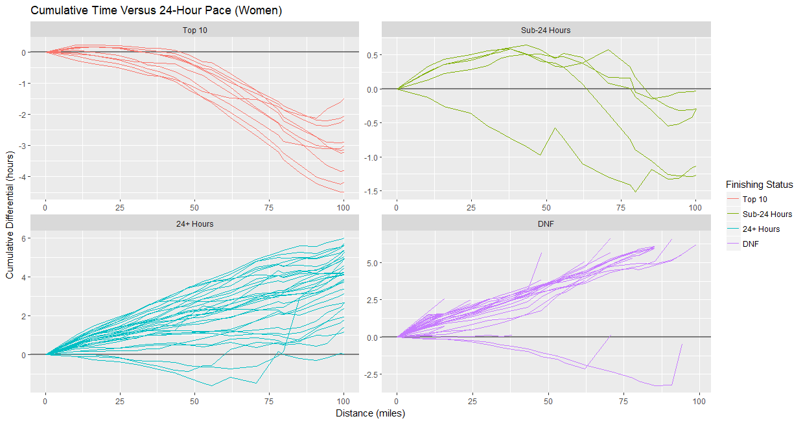

***Chart 11:*** *Elapsed time relative to silver buckle pace (women)*

We will define the “silver buckle frontier” at a particular aid station as the elapsed time (to that aid station) of the final runner who reached that age station and went on to earn a silver buckle. In other words, it’s the size of the biggest comeback from that aid station. By definition, any runner arriving after the “silver buckle frontier” did not earn a silver buckle.

Table 4 shows the silver buckle frontier for each aid station. You can see that some runners were behind pace by as much as 58 minutes between Dusty Corners (mile 38) and Michigan Bluff (mile 55.7).

|  |  |  |
| --- | --- | --- |
| **Aid Name** | **Aid Distance** | **Frontier** |
| Start | 0.0 | +0:00 |
| Lyon Ridge | 10.3 | +0:37 |
| Red Star Ridge | 15.8 | +0:44 |
| Duncan Canyon | 24.4 | +0:50 |
| Robinson Flat | 30.3 | +0:56 |
| Miller's Defeat | 34.4 | +0:53 |
| Dusty Corners | 38.0 | +0:58 |
| Last Chance | 43.3 | +0:57 |
| Devil's Thumb | 47.8 | +0:56 |
| El Dorado Creek | 52.9 | +0:59 |
| Michigan Bluff | 55.7 | +0:58 |
| Foresthill | 62.0 | +0:54 |
| Peachstone | 70.7 | +0:43 |
| Rucky Chucky | 78.0 | +0:38 |
| Green Gate | 79.8 | +0:31 |
| Auburn Lake Trails | 85.2 | +0:26 |
| Quarry Road | 90.7 | +0:15 |
| Pointed Rocks | 94.3 | +0:02 |
| Robie Point | 98.9 | -0:02 |
| Finish Line | 100.2 | -0:02 |

***Table 4:*** *Largest comeback by aid station*

To make the frontier more usable, we will add 5 minutes to each point (other than the start and finish lines, which we set to zero) and “smooth it out” by fitting a polynomial through the points. In this case, we’ll use a degree 5 polynomial. Chart 12 shows the elapsed time (relative to 24-hour pace) for all men who were ahead of pace at any point, with the silver buckle frontier overlaid. You can see that the frontier does indeed contain beneath it all the points.

By definition, all of the silver buckle winners stayed under this frontier. Conversely, all of the non-silver buckle winners either crossed the frontier (and therefore failed to finish under 24 hours) or dropped out without ever crossing it. As it happens, there were three men who never crossed the frontier yet failed to earn a silver buckle: Jim Walmsley, David Byrne and Nate Jaqua. (These are the bottom three purple lines in the chart.)

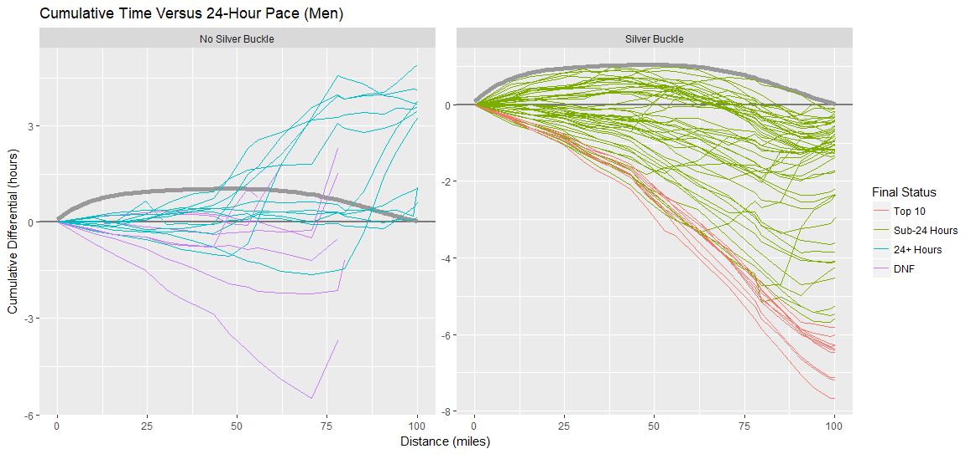

***Chart 12:*** *Elapsed time relative to silver buckle pace with frontier (men)*

Chart 13 shows the same thing for women. Unlike the men, the female silver buckle winners all stayed well under the frontier throughout the race. However, like on the men’s side, there were three women who never crossed the frontier yet failed to earn a silver buckle: Clare Gallagher, Yiou Wang and Amy Sproston.

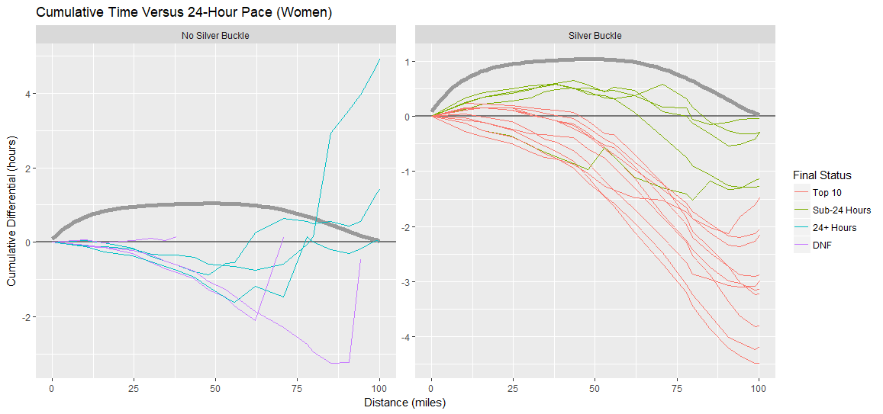

***Chart 13:*** *Elapsed time relative to silver buckle pace with frontier (men)*

Table 4 shows the complete pace chart with the official pace, the empirical pace built by our model, the buffer between the empirical pace and the silver buckle frontier and finally the frontier pace. As an example of how to read this table, consider a runner arriving at the Peachstone (mile 70.7) aid station. The official 24-hour pace to this point is 15:45. However, our model estimates, based on actual experience, that a runner arriving 22 minutes later still has a 50% likelihood of earning a silver buckle. Furthermore, a

|  |  |  |  |  |  |
| --- | --- | --- | --- | --- | --- |
| **Aid Name** | **Aid Distance** | **Official Pace** | **Empirical Pace** | **Buffer** | **Frontier** |
| Start | 0.0 | 0:00 | 0:00 | +0:00 | 0:00 |
| Lyon Ridge | 10.3 | 2:10 | 2:16 | +0:37 | 2:52 |
| Red Star Ridge | 15.8 | 3:20 | 3:26 | +0:47 | 4:12 |
| Duncan Canyon | 24.4 | 5:00 | 4:59 | +0:57 | 5:56 |
| Robinson Flat | 30.3 | 6:30 | 6:27 | +1:01 | 7:28 |
| Miller's Defeat | 34.4 | 7:15 | 7:12 | +1:03 | 8:15 |
| Dusty Corners | 38.0 | 7:55 | 7:50 | +1:04 | 8:53 |
| Last Chance | 43.3 | 8:55 | 8:45 | +1:04 | 9:49 |
| Devil's Thumb | 47.8 | 10:15 | 10:09 | +1:03 | 11:12 |
| El Dorado Creek | 52.9 | 11:20 | 11:20 | +1:01 | 12:21 |
| Michigan Bluff | 55.7 | 12:20 | 12:19 | +1:00 | 13:18 |
| Foresthill | 62.0 | 13:45 | 13:56 | +0:56 | 14:52 |
| Peachstone | 70.7 | 15:45 | 16:07 | +0:49 | 16:56 |
| Rucky Chucky | 78.0 | 17:40 | 18:02 | +0:41 | 18:42 |
| Green Gate | 79.8 | 18:20 | 18:45 | +0:39 | 19:24 |
| Auburn Lake Trails | 85.2 | 19:50 | 20:14 | +0:31 | 20:44 |
| Quarry Road | 90.7 | 21:10 | 21:43 | +0:21 | 22:03 |
| Pointed Rocks | 94.3 | 22:20 | 22:43 | +0:13 | 22:56 |
| Robie Point | 98.9 | 23:40 | 23:46 | +0:02 | 23:49 |
| Finish Line | 100.2 | 24:00 | 24:00 | +0:00 | 24:00 |

***Table 4:*** *Pace chart with silver buckle frontier*

## Biggest Comebacks

In this section, we identify those silver buckle winners who made the largest comeback (relative to empirical 24-hour pace). First, Table 5 shows the top 5 biggest male comebacks. Richard Snipes (age 42 from San Anselmo CA) was 59 minutes behind at El Dorado Creek (mile 52.9) yet rallied for a silver buckle in 23:49. Even more improbable, our model gave Ian Seabury (age 27 from Los Angeles, CA) just a 13% chance of earning a silver buckle at Dusty Corners (mile 38) yet he finished well under 24 hours with more than 40 minutes to spare.

|  |  |  |  |  |  |
| --- | --- | --- | --- | --- | --- |
| **Name** | **Max Differential** | **Silver Buckle Probability** | **Aid Station** | **Aid Distance** | **Finish** |
| Richard Snipes | +0:59 | 18% | El Dorado Creek | 52.9 | 23:49 |
| Ian Seabury | +0:58 | 13% | Dusty Corners | 38.0 | 23:19 |
| Jonathan Faryadi | +0:57 | 15% | Last Chance | 43.3 | 23:20 |
| Karl Hoagland | +0:54 | 18% | Devil's Thumb | 47.8 | 23:28 |
| Kim Espat | +0:48 | 15% | Miller's Defeat | 34.4 | 22:58 |

***Table 5:*** *Biggest comebacks (by maximum differential) for men*

Table 6 shows the same thing for women. On the women’s side, the largest comeback was Kristy McBride (age 31 from Charlevoix, MI) who was 39 minutes behind at Last Chance (mile 43.3). Of particular note is Jacqueline Merritt (age 29 from Atlanta, GA) who started very conservatively and was 14 minutes back at the first aid station, Lyon Ridge (mile 10.3). From there, however, she ran to ran to a 7th place finish and a solid silver buckle in 21:07.

|  |  |  |  |  |  |
| --- | --- | --- | --- | --- | --- |
| **Name** | **Max Differential** | **Silver Buckle Probability** | **Aid Station** | **Aid Distance** | **Finish** |
| Kristy McBride | +0:39 | 24% | Last Chance | 43.3 | 23:42 |
| Mallory Richard | +0:35 | 24% | Dusty Corners | 38.0 | 22:44 |
| Mandie Holmes | +0:35 | 24% | Dusty Corners | 38.0 | 23:42 |
| Stephanie Case | +0:31 | 28% | Last Chance | 43.3 | 23:58 |
| Jacqueline Merritt | +0:14 | 19% | Lyon Ridge | 10.3 | 21:07 |

***Table 6:*** *Biggest comebacks (by maximum differential) for women*

## Biggest Blowups

In this section, we identify those runners who were ahead of the empirical 24-hour pace by the most yet failed to earn a silver buckle. Table 7 shows the top 5 male blow ups. Not surprisingly, Jim Walmsley tops the list with a buffer of nearly five and a half hours under silver buckle pace at Peachstone (mile 70.7). Our model gave David Byrne a 95% chance of a silver buckle after coming into Peachstone with a buffer of over two hours. Like Walmsley, however, David later dropped. Jason Mintz (age 37 from Syracuse, NY) and Joel Frost-Tift (age 29 from Huntington Park, CA) gave up buffers of more than an hour but stuck it out and finished the race.

|  |  |  |  |  |  |
| --- | --- | --- | --- | --- | --- |
| **Name** | **Max Differential** | **Silver Buckle Probability** | **Aid Station** | **Aid Distance** | **Finish** |
| Jim Walmsley | -5:29 | 100% | Peachstone | 70.7 | DNF |
| David Byrne | -2:13 | 95% | Peachstone | 70.7 | DNF |
| Jason Mintz | -1:37 | 90% | Peachstone | 70.7 | 27:13 |
| Nate Jaqua | -1:10 | 83% | Peachstone | 70.7 | DNF |
| Joel Frost-Tift | -1:04 | 86% | Devil's Thumb | 47.8 | 27:41 |

***Table 7:*** *Biggest blowups (by maximum differential) for men*

Table 8 shows the same for women. Clare Gallagher was more than three hours ahead of silver-buckle pace and in third place at Auburn Lake Trails (mile 85.2) but later dropped. Another notable blowup was Yiou Wang who arrived at Foresthill (mile 62) in the lead and more than two hours ahead of 24-hour pace but also later dropped.

|  |  |  |  |  |  |
| --- | --- | --- | --- | --- | --- |
| **Name** | **Max Differential** | **Silver Buckle Probability** | **Aid Station** | **Aid Distance** | **Finish** |
| Clare Gallagher | -3:15 | 100% | Auburn Lake Trails | 85.2 | DNF |
| Yiou Wang | -2:07 | 95% | Foresthill | 62.0 | DNF |
| Kaci Lickteig | -1:36 | 92% | Michigan Bluff | 55.7 | 24:02 |
| Emily Harrison | -0:52 | 81% | Devil's Thumb | 47.8 | 25:25 |
| Sarah Keyes | -0:45 | 75% | Foresthill | 62.0 | 28:55 |

***Table 8:*** *Biggest blowups (by maximum differential) for women*

## Steadiest Performance

In this section, we identify those runners who earned a silver buckle with the smallest deviation from the empirical 24-hour pace. We will measure this by the range between each runner’s largest deviation above and below pace. These runners stayed on pace and steady all day, arriving in Auburn just under the cutoff. Table 9 shows the top five steadiest performances for men. Angel Ochoa (age 29 from Tucson, AZ) was 21 minutes behind pace at Dusty Corners (mile 38) and 14 minutes ahead of pace at Quarry Road (mile 90.7), ultimately finishing with 11 minutes to spare in 23.49.

|  |  |  |  |  |
| --- | --- | --- | --- | --- |
| **Name** | **Max** | **Min** | **Range** | **Finish** |
| Angel Ochoa | +0:21 | -0:14 | 0:35 | 23:49 |
| Matt Zuchetto | +0:08 | -0:31 | 0:39 | 23:34 |
| Paulo Medina | +0:18 | -0:23 | 0:41 | 23:46 |
| Andrew Stevens | +0:43 | -0:07 | 0:50 | 23:55 |
| Philip Sanderson | +0:30 | -0:19 | 0:50 | 23:55 |

***Table 9:*** *Steadiest silver-buckle performance for men*

Table 10 shows the same for women. Stephanie Case (age 35 from Geneva, Switzerland) was 31 minutes behind pace at Last Chance (mile 43.3) and 8 minutes ahead of pace at Auburn Lake Trails (mile 85.2), ultimately becoming the final silver buckle winner in 23:58. Also noteworthy are the performances of Mandie Holmes (age 31 from Mountain View, CA) and Mallory Richard (age 32 from Winnipeg, Canada) who both reached their peak differential at the finish line.

|  |  |  |  |  |
| --- | --- | --- | --- | --- |
| **Name** | **Max** | **Min** | **Range** | **Finish** |
| Stephanie Case | +0:31 | -0:08 | 0:39 | 23:58 |
| Mandie Holmes | +0:35 | -0:18 | 0:54 | 23:42 |
| Kristy McBride | +0:39 | -0:32 | 1:11 | 23:42 |
| Stephanie Howe Violett | +0:00 | -1:31 | 1:31 | 22:52 |
| Mallory Richard | +0:35 | -1:17 | 1:52 | 22:44 |

***Table 10:*** *Steadiest silver-buckle performance for women*

## Most Unconventional Pacing

In this section, we examine the very unconventional pacing strategy of one particular runner: Andrew Stevens (age 40 from Stourport, England). Andrew got off to a strong start and arrived at Lyon Ridge (mile 10.3) seven minutes ahead of 24-hour pace. Our model gave him a 67% chance of a silver-buckle at that early point. From there, however, things slowly deteriorated. He gave back time at each of the next nine aid stations, eventually arriving at Peachstone (mile 70.7) a full 43 minutes behind pace. From here he began to rally, but not fast enough for our model to improve his likelihood of a silver buckle. In fact, as late as Auburn Lake Trails (mile 85.2), the model gave him just a 22% likelihood of a sub-24 hour finish. However, he made up a deficit of 26 minutes in only 15 miles and finished in 23:55.

Chart 10 shows Andrew’s likelihood of finishing under 24 hours at each aid station (in red) compared with the other 75 silver buckle winners (in gray). You can see that he is a clear outlier. In fact, he was the last of the eventual silver buckle winners to arrive at Auburn Lake Trails (mile 85.2) and did so a full 28 minutes the rest.

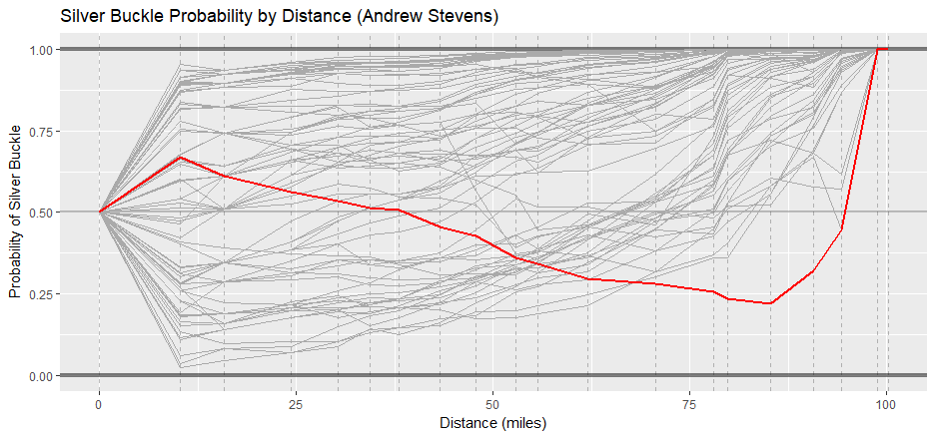

***Chart 10:*** *Silver buckle probability for Andrew Stevens*